
Awards Booking Form

The Rising 20 | 2026

A DealMakers Pathfinders Initiative

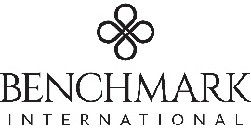



Event Sponsors:

Join us at 18h00 on Tuesday 27 October 2026 at The Venue | Nine Yards (167 Jan Smuts Avenue, Parktown North ( https://www.thevenue.co.za/venues/nine-yards )) for a cocktail evening as we announce the Rising 20 for 2026.

Company:
Contact :
Email:
Cost per person  R1 250 excl VAT |  |  |  | No of Guests:
Please advise if there are dietary requirements we need to be aware of.
The kitchen is Halaal certified and there will be gluten free and vegetarian
options available on the evening. Due to escalating costs, Kosher
meals can be accommodated, but there will be a surcharge of R1,500 pp.
Please submit the names of your guests by no later than Tuesday 20 October 2026.

Invoicing Details:
Invoices will be issued immediately and are payable prior to the event.
Company:
PO Number (if applicable):
Attention: |  |  |  |  |  | VAT No:
Email:
Physical Address:

Signature: ______________________ Date: _________________

Bookings or Queries, contact:

Vanessa |reception@gleason.co.za | 083 775 2995 (whats app)

